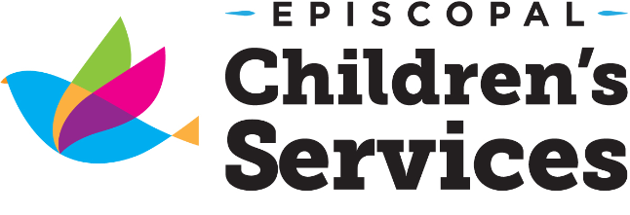
8443 Baymeadows Road
Jacksonville, Florida 32256
904.726.1500 Ext 299

Earning for your CDA is now convenient, fast and fun!
CDA Candidates will
- acquire professional development training in eight subject areas required by the Council for Professional Recognition to earn a National CDA
- network with other aspiring CDA Candidates while building their skill set in the areas such as
  - Planning a Safe, Healthy, Learning Environment
  - Understanding the Principles of Child Development
- build a Professional Portfolio by developing impressive Reflective Competency Statements and collecting the six required Resource Items
- work with fellow candidates to refine previously acquired skills while adopting fresh, innovative ideas that will improve the quality of care and interaction provided to the children and families they serve.

Want to know more?

Attend the
CDA Orientation
August 23rd
6:30 pm-7:30 pm
at our Baymeadows office.

Fall 2018 CDA Class Schedule
*Online courses are available through Smart Horizon’s Online CDA Training Program*
Tuesday/ Thursday Class
August 28th- November 8th
6:00pm-8:00pm
Saturday Class
August 25th- November 3rd
9:00am-5:00pm
Every other Saturday

Portfolio Workshops
Monthly on the 2nd Saturday
9:00am-11:00am
*no workshops will be held on holiday weekends

Frequently Asked Questions
How do I register?
Submit an application to Danesha Davis at ddavis@ecs4kids.org
Are scholarships available?
The Office of Early Learning is now working with T.E.A.C.H. to provide funding for credentialing for child care professionals.
How do I apply for a T.E.A.C.H. scholarship?
If your center director is not familiar with the process, contact Danesha Davis for support at (904) 726-1500 ext. 299 or ddavis@ecs4kids.org
What do I need to bring to a CDA class or Portfolio Workshop?
- A one or two inch binder
- 10 dividers
- 30 page protectors
- 12 small mailing labels
- Black sharpie marker
- Medium size Post-it Notes
What about technology?
Candidates will need access to a working computer and internet.
What if I already have credits towards a CDA?
You may qualify for individualized support in our CDA Mentorship Program if you have at least 10 hours for each of the 8 Subject Areas required by The Council for Professional Recognition. Contact Danesha Davis at (904) 726-1500 ext. 299 or ddavis@ecs4kids.org for more information.
Spring CDA Training 2019
Orientation January 3rd 6:30pm-7:30pm Baymeadows location
January 8th – March 7 ^{th} every Tuesday and Thursday
January 5th – March 2nd every other Saturday

Summer Fast Track 2019
May 18th - July 9th
6:30 pm - 8:00 pm every Tuesday
&
9:00 am – 5:00 pm every other Saturday

Funded in whole or part by the Kids Hope Alliance

