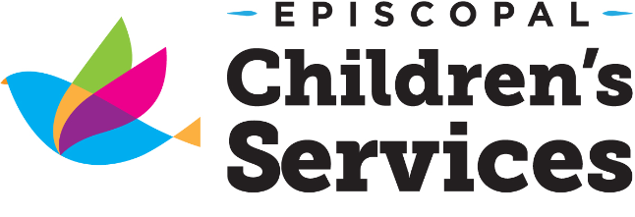
8443 Baymeadows Road
Jacksonville, Florida 32256
904.726.1500 Ext 299

Earning for your CDA is now convenient, fast and fun!
CDA Candidates will
- acquire professional development training in eight subject areas required by the Council for Professional Recognition to earn a National CDA
- network with other aspiring CDA Candidates while building their skill set in the areas such as
  - Planning a Safe, Healthy, Learning Environment
  - Understanding the Principles of Child Development
- build a Professional Portfolio by developing impressive Reflective Competency Statements and collecting the six required Resource Items
- work with fellow candidates to refine previously acquired skills while adopting fresh, innovative ideas that will improve the quality of care and interaction provided to the children and families they serve.

Want to know more?

Attend the
CDA Orientation
August 15th
6:00 pm-7:00 pm
at our Baymeadows office.

Fall 2017 CDA Class Schedule
*Online courses are available at the request of the candidate through the TEACH Scholarship Program*
Tuesday/ Thursday Class
August 22nd- November 9th
6:00pm-8:00pm
Saturday Class
August 26th- November11th
9:00am-5:00pm
Every other Saturday

Portfolio Workshops
Monthly on the 2nd Saturday
9:00am-11:00am
*no workshops will be held on holiday weekends

Frequently Asked Questions
How do I register?
Submit an application to Danesha Davis at ddavis@ecs4kids.org
Are scholarships available?
The Office of Early Learning is now working with T.E.A.C.H. to provide funding for credentialing for child care professionals.
How do I apply for a T.E.A.C.H. scholarship?
If your center director is not familiar with the process, contact Danesha Davis for support at (904) 726-1500 ext. 299 or ddavis@ecs4kids.org
What do I need to bring to a CDA class or Portfolio Workshop?
- A one or two inch binder
- 9 dividers
- 30 page protectors
- 12 small mailing labels
- Black sharpie marker
- Medium size Post-it Notes
What about technology?
Candidates will need access to a working computer and internet.
What if I already have credits towards a CDA?
You may qualify for individualized support in our CDA Mentorship Program if you have at least 10 hours for each of the 8 Subject Areas required by The Council for Professional Recognition. Contact Danesha Davis at (904) 726-1500 ext. 299 or ddavis@ecs4kids.org for more information.
Spring CDA Training 2018
Orientation January 2nd 6pm-7pm Baymeadows location
January 9th – March 8th every Tuesday and Thursday
January 6th – March 17th every other Saturday

Summer Fast Track 2018
May 15th - July 10th
6:00 pm - 8:00 pm every Tuesday
&
9:00 am – 5:00 pm every other Saturday

Funded in whole or part by the Jacksonville Children's Commission

